**1.** Write a Python script to sort (ascending and descending) a dictionary by value.

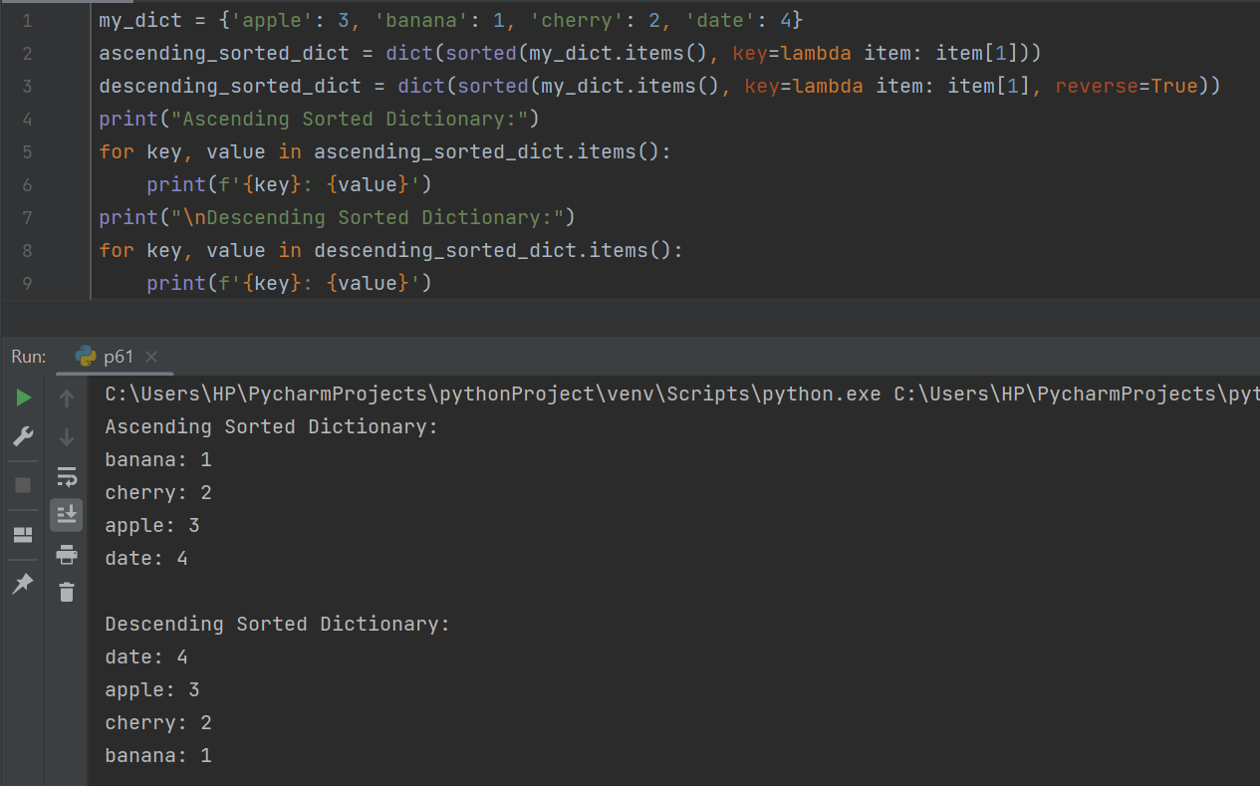

**2.** Write a Python script to add a key to a dictionary.

Sample Dictionary : {0: 10, 1: 20}

Expected Result : {0: 10, 1: 20, 2: 30}

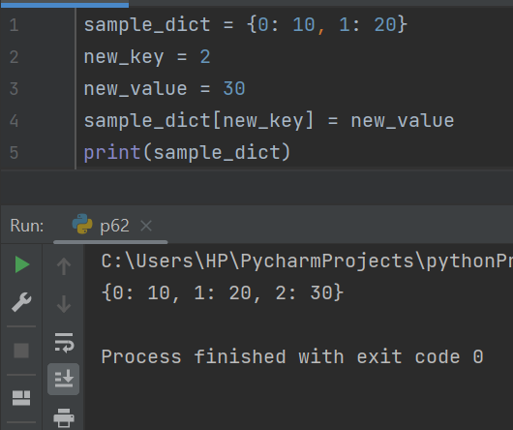

**3.** Write a Python script to concatenate following dictionaries to create a new one.

Sample Dictionary :

dic1={1:10, 2:20}

dic2={3:30, 4:40}

dic3={5:50,6:60}

Expected Result : {1: 10, 2: 20, 3: 30, 4: 40, 5: 50, 6: 60}

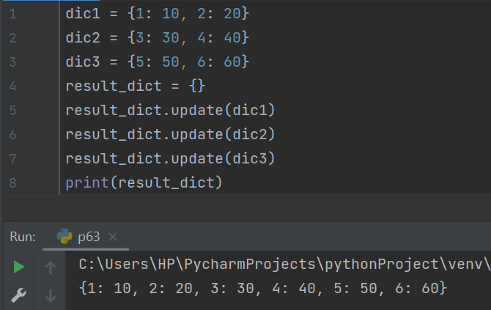

**4.** Write a Python script to check if a given key already exists in a dictionary.

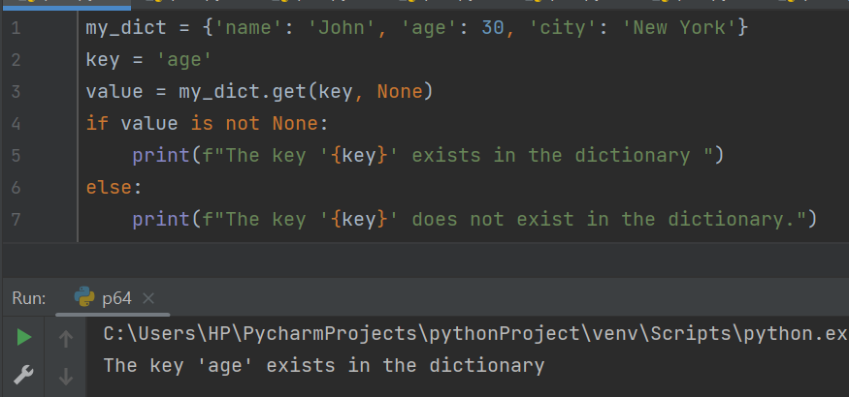

**5.** Write a Python program to iterate over dictionaries using for loops.

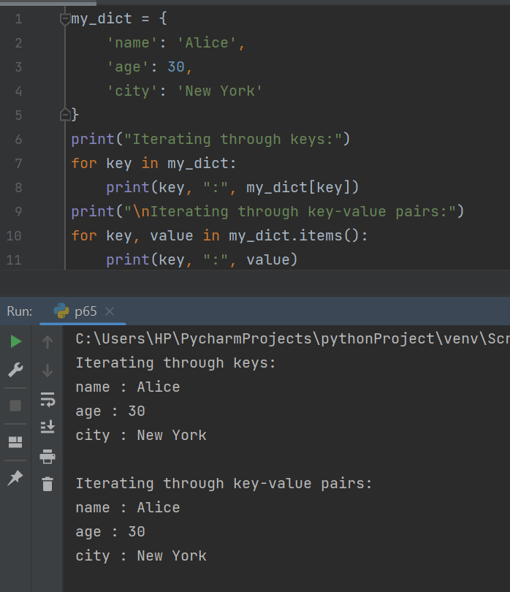

**6.** Write a Python script to generate and print a dictionary that contains a number (between 1 and n) in the form (x, x*x).

Sample Dictionary ( n = 5) :

Expected Output : {1: 1, 2: 4, 3: 9, 4: 16, 5: 25}

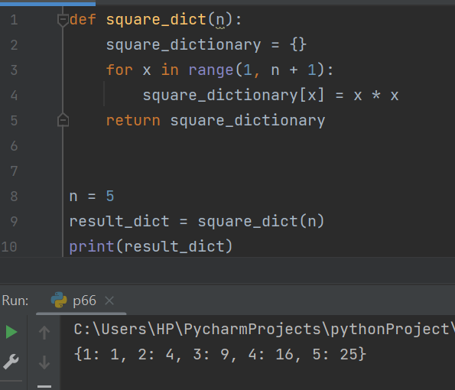

**7.** Write a Python script to merge two Python dictionaries.

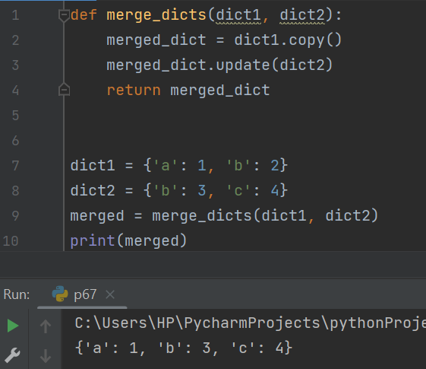

**8.**  Write a Python program to sum all the items in a dictionary.

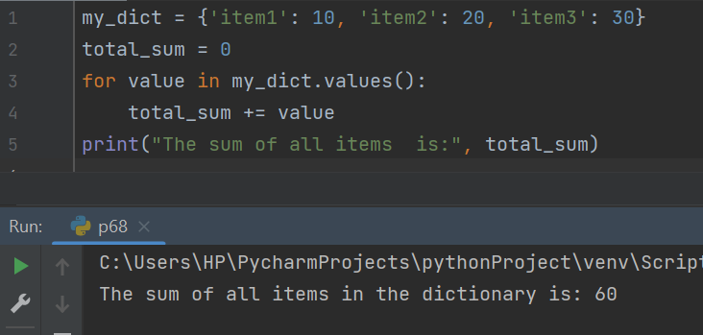

**9.** Write a Python program to multiply all the items in a dictionary.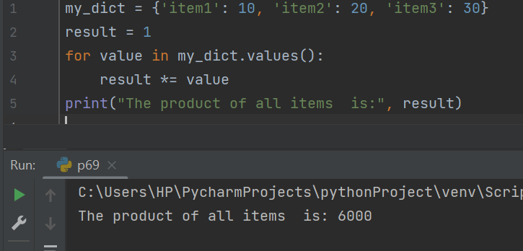

**10.** Write a Python program to remove a key from a dictionary.

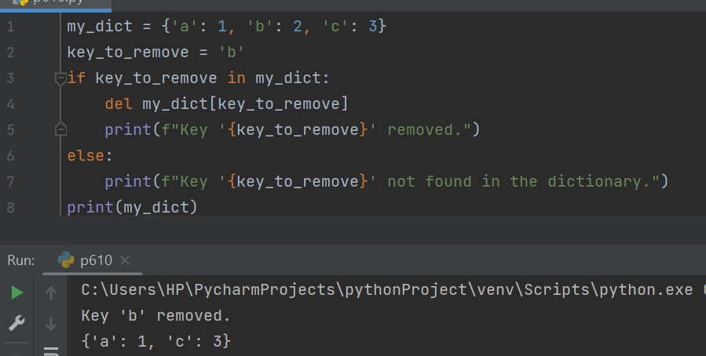

**11.** Write a Python program to sort a dictionary by key.

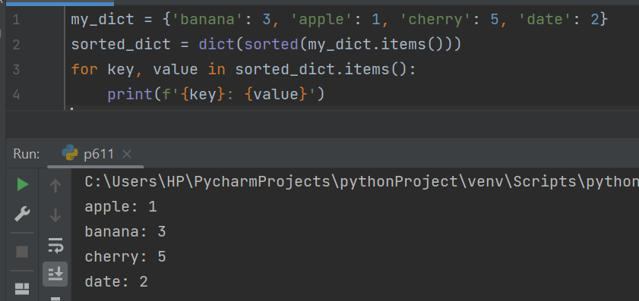

**12.** Write a Python program to get the maximum and minimum value in a dictionary.

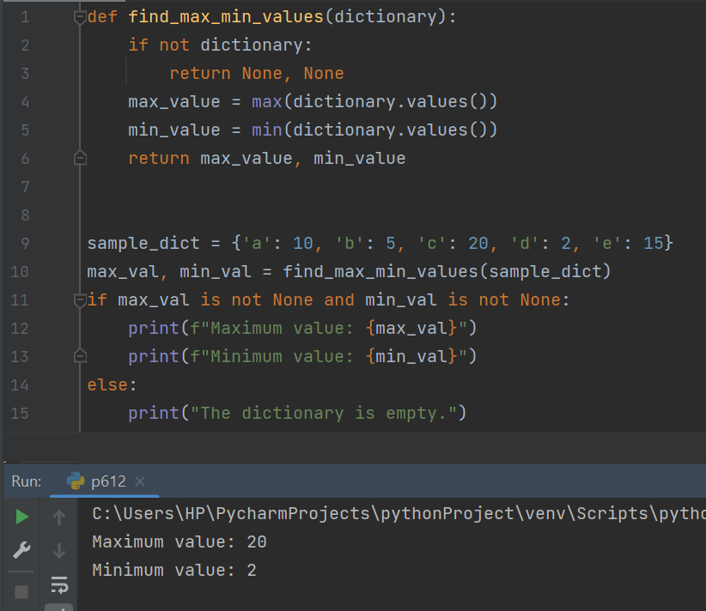

**13.** Write a Python program to remove duplicates from Dictionary.

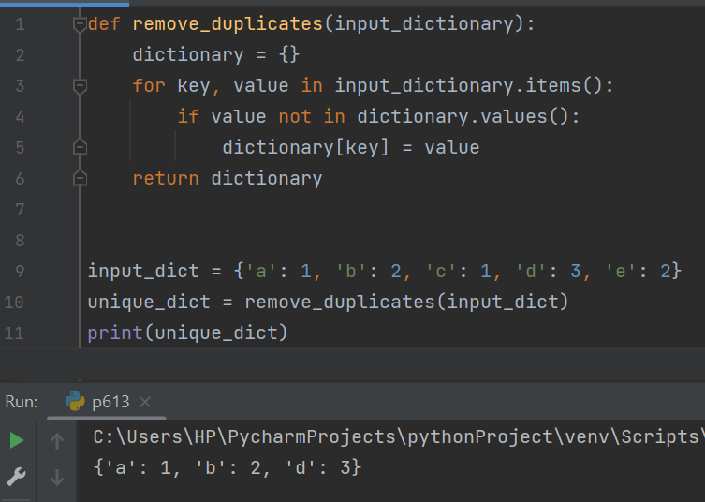

**14.** Write a Python program to check a dictionary is empty or not.

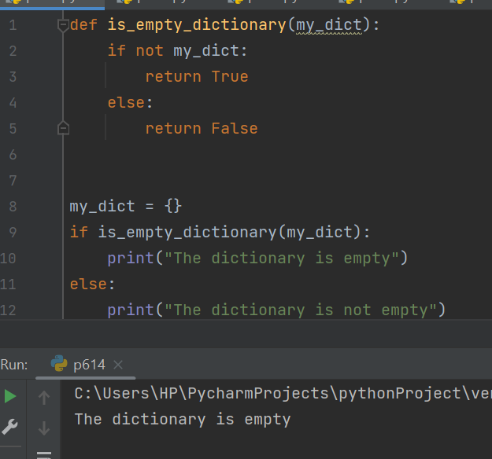

**15.** Write a Python program to combine two dictionary adding values for common keys.

d1 = {'a': 100, 'b': 200, 'c':300}

d2 = {'a': 300, 'b': 200, 'd':400}

Sample output: Counter({'a': 400, 'b': 400, 'd': 400, 'c': 300})

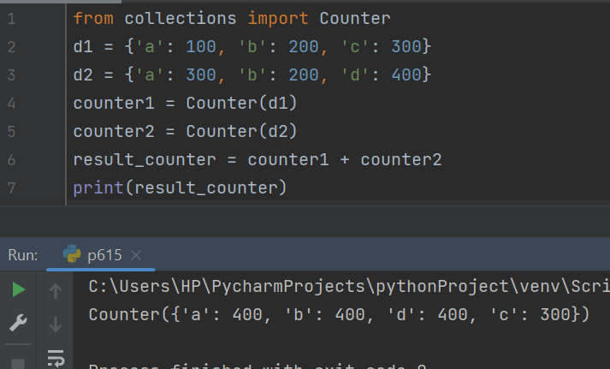

**16.** Write a Python program to find the highest 3 values in a dictionary.

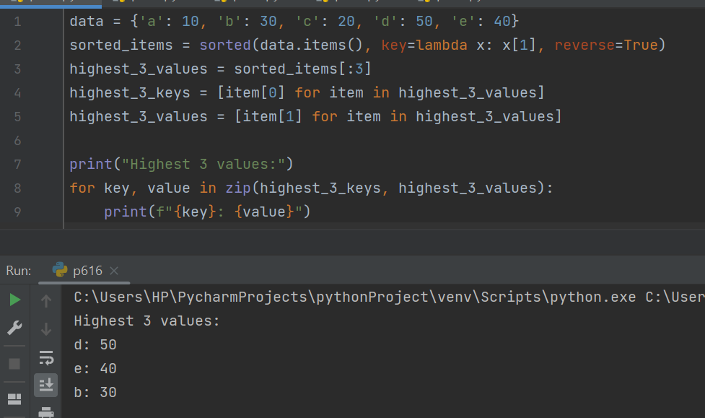

**17.** Write a Python program to match key values in two dictionaries.

Sample dictionary: {'key1': 1, 'key2': 3, 'key3': 2}, {'key1': 1, 'key2': 2}

Expected output: key1: 1 is present in both x and y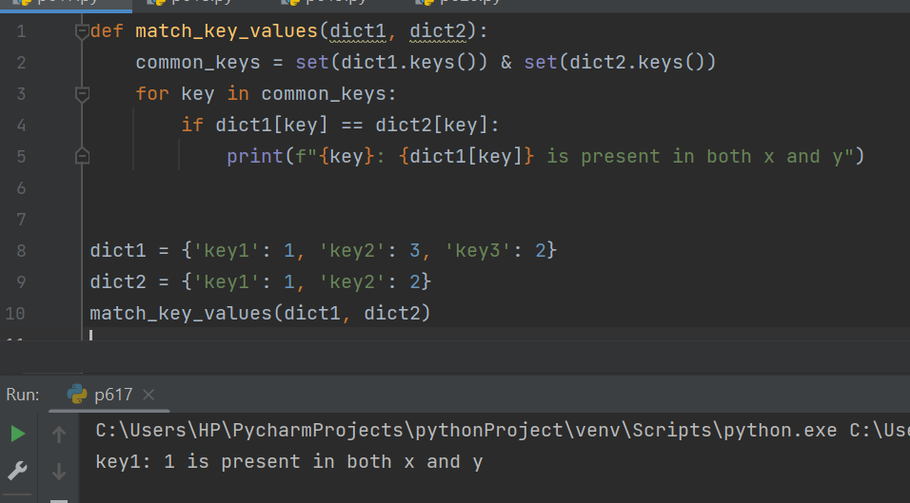

**18.** Write a Python program to check if all dictionaries in a list are empty or not.

Sample list : [{},{},{}]

Return value : True

Sample list : [{1,2},{},{}]

Return value : False

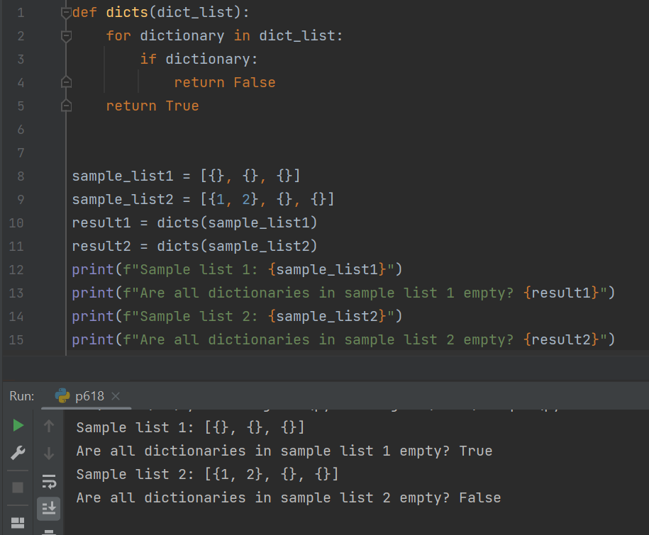

**19.** Write a Python program to remove duplicates from a list of lists.

Sample list : [[10, 20], [40], [30, 56, 25], [10, 20], [33], [40]]

New List : [[10, 20], [30, 56, 25], [33], [40]]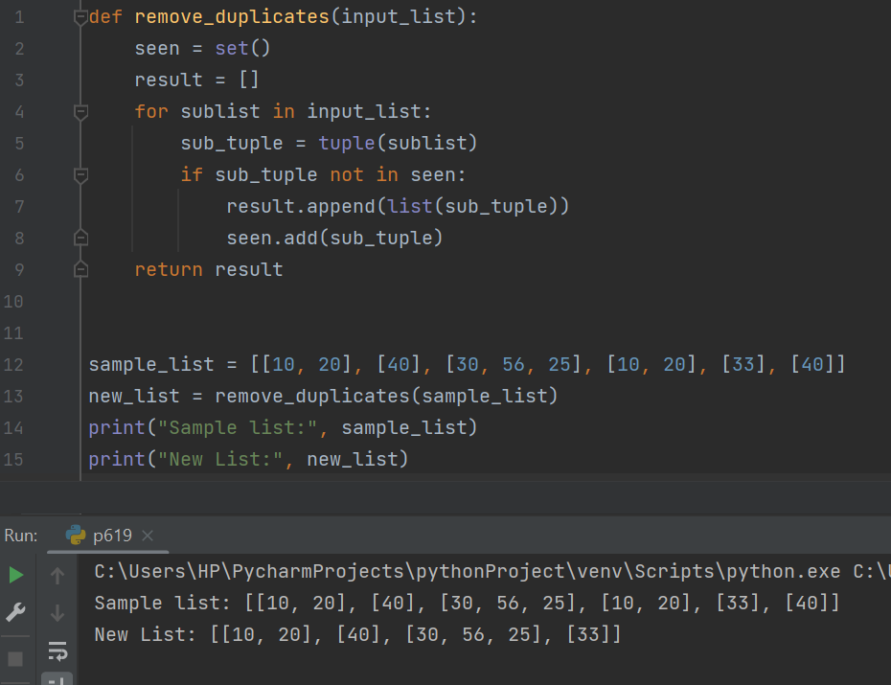

**20.** Write a Python program to extend a list without append.

Sample data: [10, 20, 30]

[40, 50, 60]

Expected output : [40, 50, 60, 10, 20, 30]

